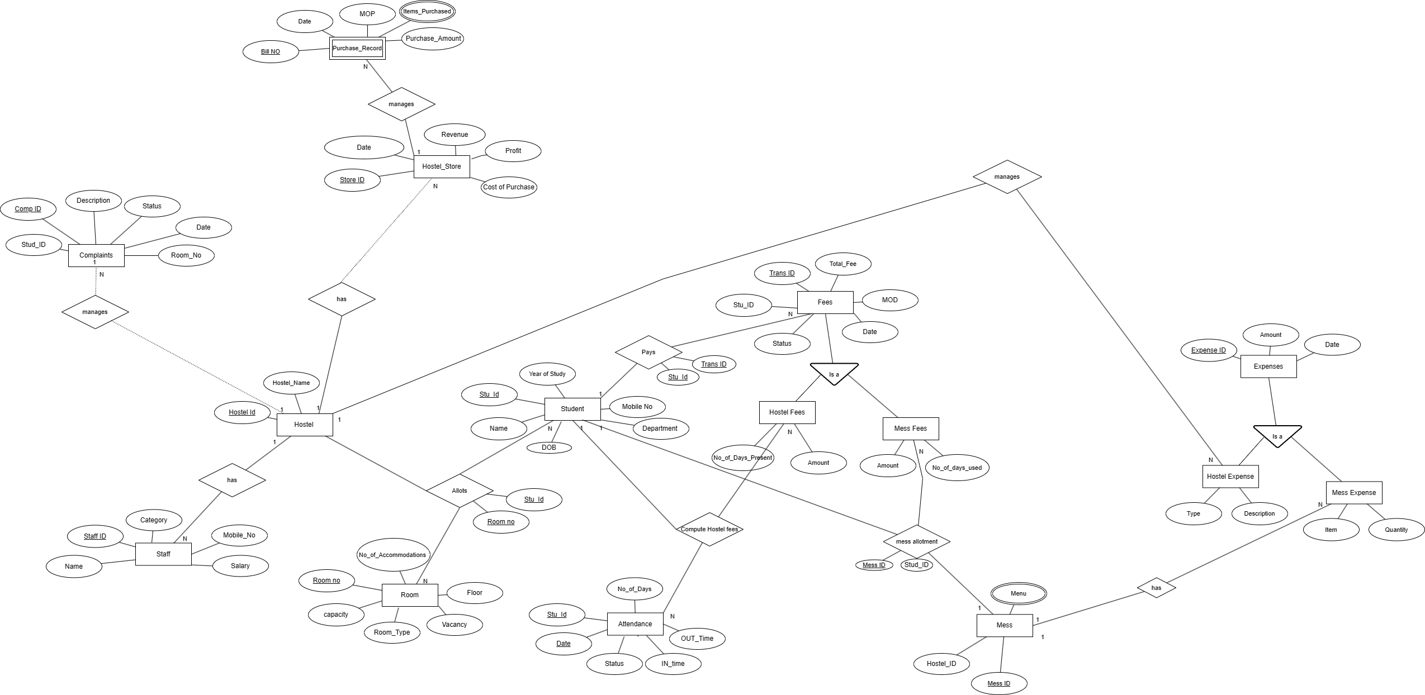

**DDL COMMANDS**

create table EXPENSE ( alter table EXPENSE add typeofexpense char;

exp_id varchar(50),

expense_date date,amount int );

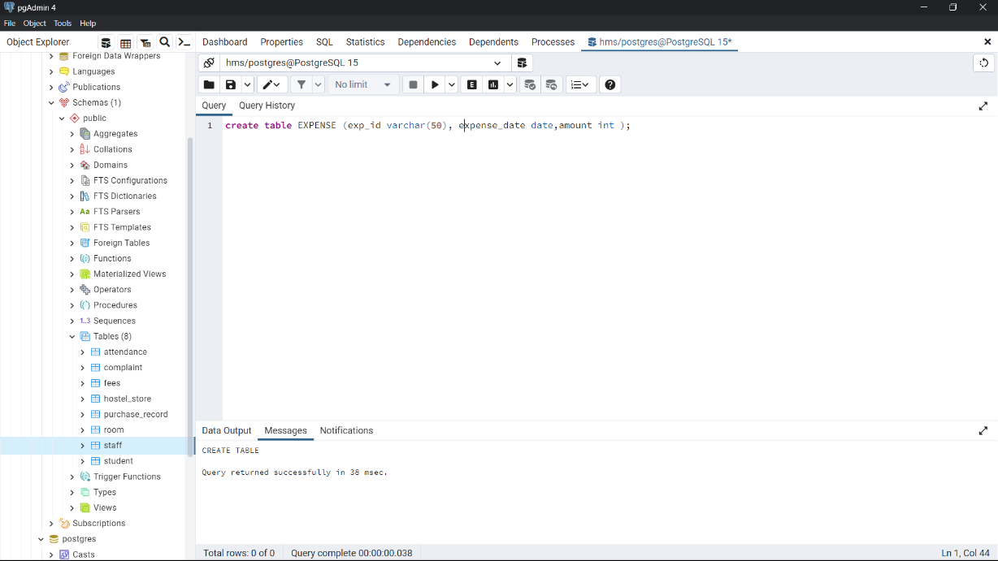 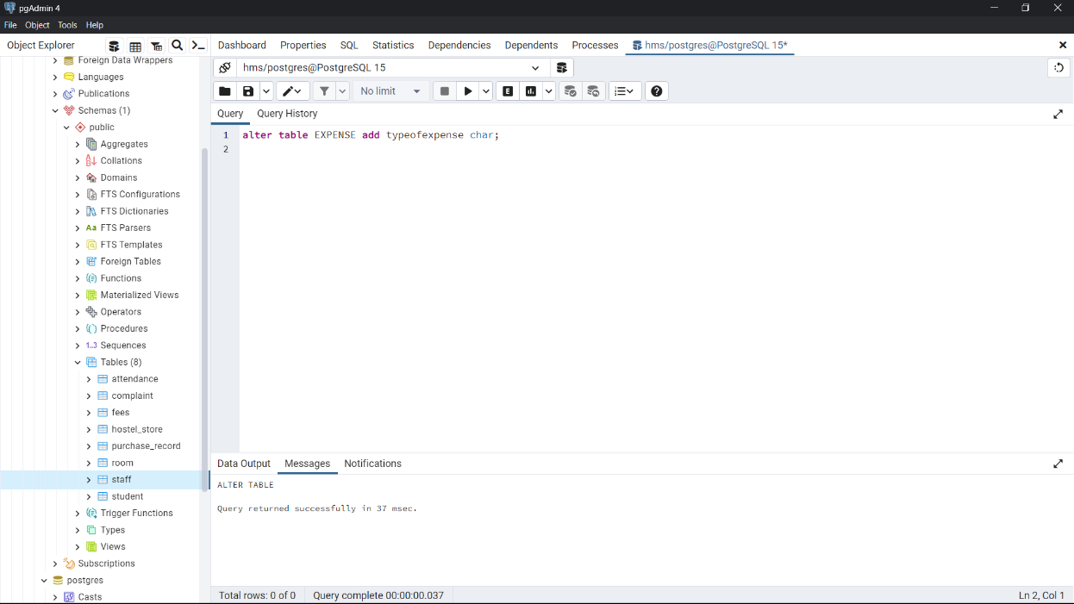

truncate table EXPENSE; drop table EXPENSE;

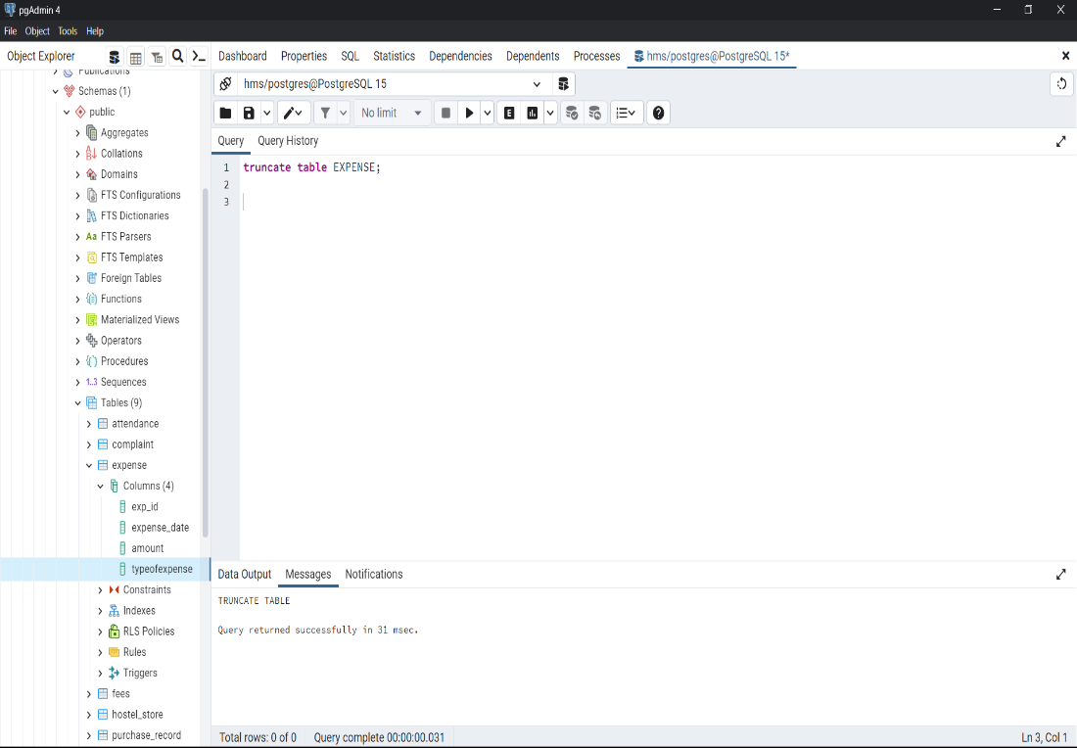 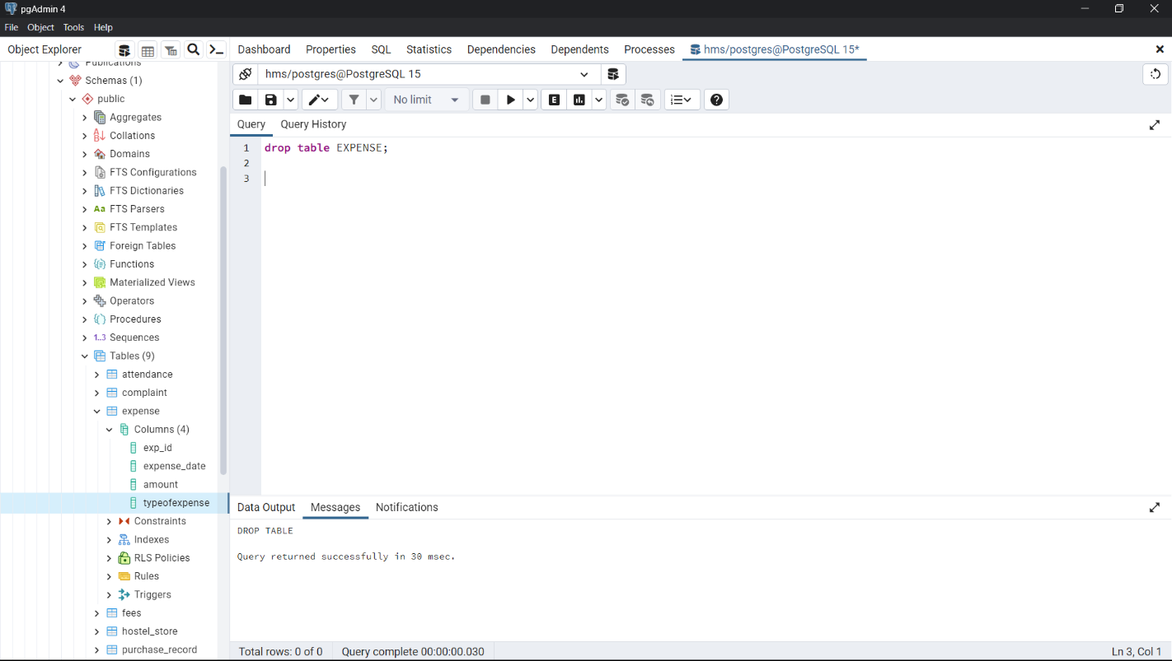

**DML COMMANDS**

insert into EXPENSE(amount) VALUES (1000); update EXPENSE set amount=5000 WHERE amount=1000;

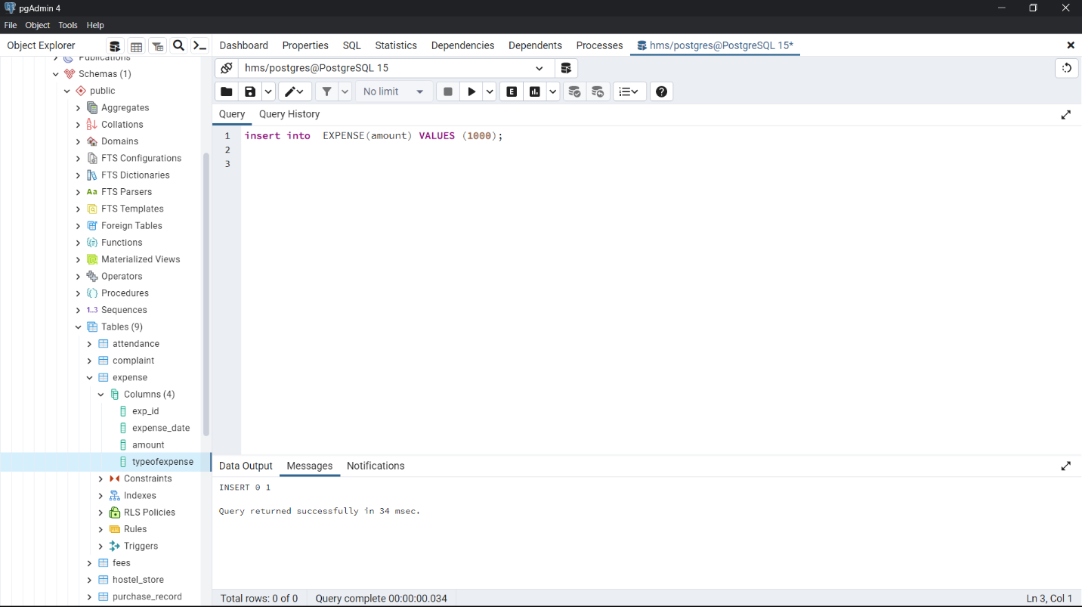 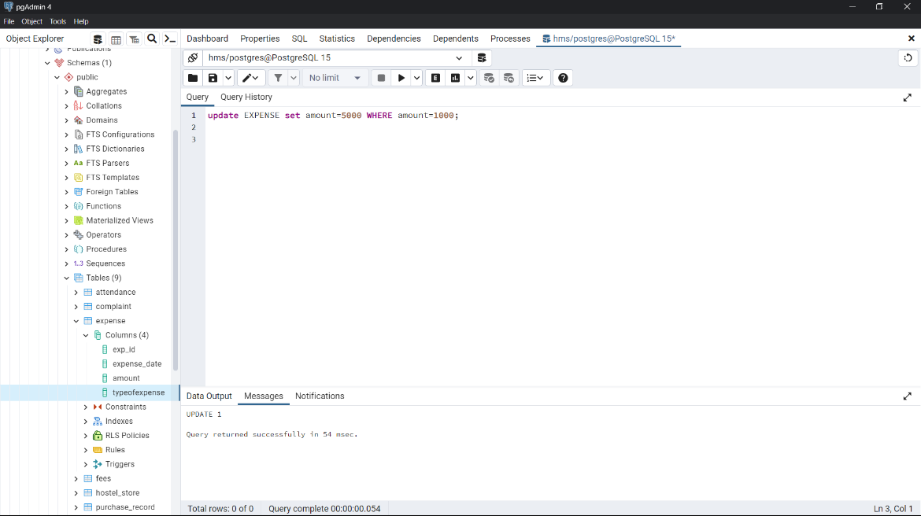

delete from EXPENSE where amount=5000;

